3mm double color LED Light

Overview  
 This course will use the Raspberry Pi's GPIO pin to light up the two-color LED lights.

Experimental Materials

RaspberryPi *1

breadboard *1

Double-Color led *1

Dupont Line

Ready to work  
1. Install python interpreter in your Raspberry Pi system  
2. Install the RPi.GPIO library in your Raspberry Pi system  
3. Install the wiringPi library in your Raspberry Pi system  
See the attached "Installing a Python Interpreter and Corresponding Libraries in a Raspberry Pi System" for details.

Product description

I. Introduction:

The double color LED module is made of a plug-in double color LED and controls the display color of the LED lamp through three pins (one of which is GND). This products are widely used in electronic dictionaries, PDA, MP3, headphones, digital cameras, VCD, DVD, car audio, communications, computers, chargers, amplifiers, instruments, gifts, electronic toys and mobile phones and many other fields. Use the Raspberry Pi to control the module for lighting effects.

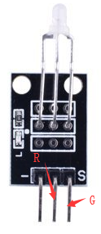

characteristic parameters

◆Emission color: green + red ◆ diameter: 3mm  
◆ Use voltage (V): 2.0-2.5 ◆ Use current (mA): 10  
◆Emission angle: 150 ◆ Wavelength (nM):571+644  
◆Luminous intensity (MCD):20-40;40-80 ◆ Stand type: Long leg

Wiring diagram

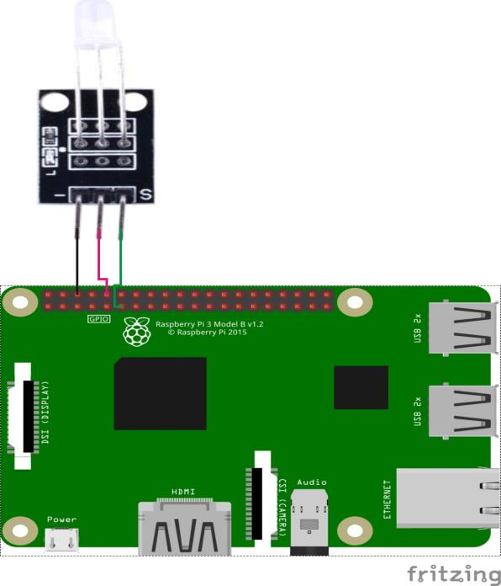

Sample code

1. Python code

#!/usr/bin/env python

import RPi.GPIO as GPIO

import time

colors = [0xFF00, 0x00FF]

pins = {'pin_R':10, 'pin_G':11} # pins is a dict

GPIO.setmode(GPIO.BOARD) # Numbers GPIOs by physical location

for i in pins:

GPIO.setup(pins[i], GPIO.OUT) # Set pins' mode is output

p_R = GPIO.PWM(pins['pin_R'], 2000) # set Frequece to 2KHz

p_G = GPIO.PWM(pins['pin_G'], 2000)

p_R.start(0) # Initial duty Cycle = 0(leds off)

p_G.start(0)

def map(x, in_min, in_max, out_min, out_max):

return (x - in_min) * (out_max - out_min) / (in_max - in_min) + out_min

def setColor(col): # For example : col = 0x112233

R_val = (col & 0xFF00) >> 8

G_val = (col & 0x00FF) >> 0

R_val = map(R_val, 0, 255, 0, 100)

G_val = map(G_val, 0, 255, 0, 100)

p_R.ChangeDutyCycle(R_val) # Change duty cycle

p_G.ChangeDutyCycle(G_val)

try:

while True:

for col in colors:

setColor(col)

time.sleep(0.5)

except KeyboardInterrupt:

p_R.stop()

p_G.stop()

for i in pins:

GPIO.output(pins[i], GPIO.HIGH) # Turn off all leds

GPIO.cleanup()

2. C code

#include <wiringPi.h>

#include <softPwm.h>

#include <stdio.h>

typedef unsigned char uchar;

#define LedPinRed 16

#define LedPinGreen 0

void ledInit(void)

{

softPwmCreate(LedPinRed, 0, 100);

softPwmCreate(LedPinGreen,0, 100);

}

uchar map(uchar val, uchar in_min, uchar in_max, uchar out_min, uchar out_max)

{

uchar tmp = 0;

tmp = (val - in_min) * (out_max - out_min) / (in_max - in_min) + out_min;

return tmp;

}

void ledColorSet(uchar r_val, uchar g_val)

{

uchar R_val, G_val;

R_val = map(r_val, 0, 255, 0, 100);

G_val = map(g_val, 0, 255, 0, 100);

softPwmWrite(LedPinRed, R_val);

softPwmWrite(LedPinGreen, G_val);

}

int main(void)

{

int i;

if(wiringPiSetup() == -1)

{

printf("setup wiringPi failed !\n");

return -1;

}

ledInit();

while(1)

{

ledColorSet(0xff,0x00); //red

delay(1000);

ledColorSet(0x00,0xff); //green

delay(1000);

}

return 0;

}

Experimental phenomena

The double color LED emits red and green light in cycle.